**Cyber Security Project Report**

**National University of Computer and Emerging Sciences**

**Password Manager**

**Batch: 2023**

**Section: CY-3A**

**Group Members**

Muhammad Hammad (23K-2005)

Muhammad Sami Ashfaq (23K-2031)

**Professor**

Fahad Samad

**Department of Cyber Security**

**National University of Computer and Emerging Sciences – FAST Karachi Campus**

**Acknowledgement**

We would like to express our sincere gratitude and appreciation to our supervisor Mr. Fahad Samad for their inspiration, expert guidance and supervision during the research work on completing the dissertation in time.

**Abstract**

This paper presents the design and implementation of an obstacle-avoiding robot using a combination of components including a car chassis, TT gear motors, Arduino Uno microcontroller, ultrasonic sensor, L298N motor driver, electrical insulation tape, 7-12 V DC battery, and jumper wires. The robot autonomously navigates its environment by detecting obstacles with the ultrasonic sensor and adjusting its movement accordingly. The integration of these components enables the robot to effectively maneuver through its surroundings, making it suitable for various applications in robotics, automation, and education.

**Project Overview**

The obstacle-avoiding robot is a versatile and innovative system designed to navigate autonomously through its environment while avoiding obstacles in its path. Built upon a sturdy car chassis, the robot is equipped with TT gear motors for movement control. An Arduino Uno microcontroller serves as the brain of the system, coordinating the robot's actions. The key component, an ultrasonic sensor, detects obstacles, enabling the robot to make real-time decisions about its trajectory. Motor control is facilitated by the L298N motor driver, ensuring smooth and precise movement. Electrical insulation tape secures connections, while a 7-12 V DC battery powers the entire system. Jumper wires ensure seamless connectivity between components. This project amalgamates various technologies to create a functional and adaptable robot capable of navigating diverse environments, making it ideal for applications in robotics, automation, and education.

**Introduction**

The obstacle-avoiding robot represents a significant advancement in autonomous robotics, leveraging a combination of components and technologies to navigate its surroundings intelligently. In today's world, where automation plays an increasingly crucial role across industries, the ability to develop robots capable of independent movement and decision-making is paramount. This project aims to showcase a practical implementation of such technology, utilizing a blend of hardware components including a robust car chassis, precise TT gear motors, and sophisticated control systems such as the Arduino Uno microcontroller. At the heart of the robot's functionality lies the ultrasonic sensor, which enables real-time detection of obstacles, allowing the robot to adjust its path autonomously. By integrating these components, the obstacle-avoiding robot promises to deliver a versatile and adaptable solution suitable for a wide range of applications, from industrial automation to educational robotics projects. This introduction sets the stage for exploring the intricacies of the project and its potential impact on the field of robotics and automation. Through this project, participants will not only gain proficiency in designing and implementing digital circuits but will also develop critical problem-solving skills and a deeper understanding of robotics algorithms.

**Obstacle Avoiding Robot Circuit Diagram:**

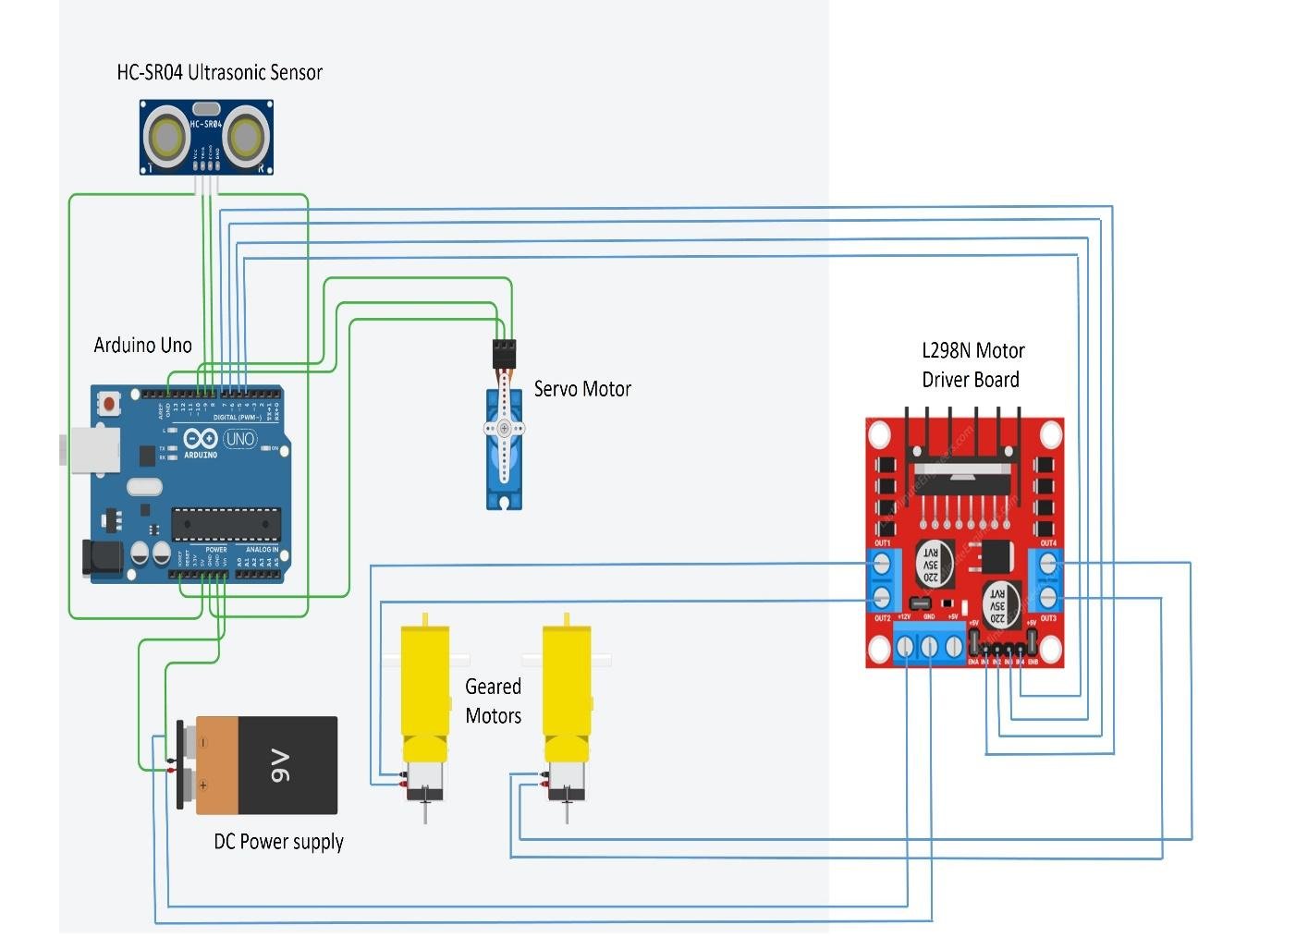

**Components Required:**

∙ Car Chassis

∙ TT Gear Motors

∙ Arduino Uno

**.** Ultrasonic Sensor

**.** SG 90 Servo Motor

**.** L298N Motor Driver

**.** Electrical Insulation Tape

**.** 7-12 V DC Battery

**.** Jumper Wires

**Explanation of the Components**

**1. Car Chassis:**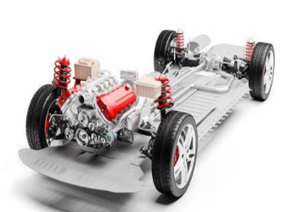

The car chassis is essentially the framework or structure upon which the various components of a vehicle are mounted. It serves as the foundation that supports the body, engine, suspension, steering, and other mechanical parts. It includes a car chassis, wheels, castor wheel and a battery pack.

**2. TT Gear Motors:** 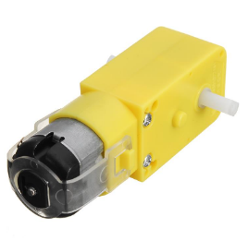

TT gear motors, also known as TT motors or TT gearbox motors, are a type of geared motor commonly used in robotics, hobbyist projects, and small-scale automation applications. The "TT" in TT gear motors typically stands for "Tamiya Twin," referring to the Tamiya brand, which popularized these motors for use in model kits and other DIY projects.

**3. Arduino Uno:** 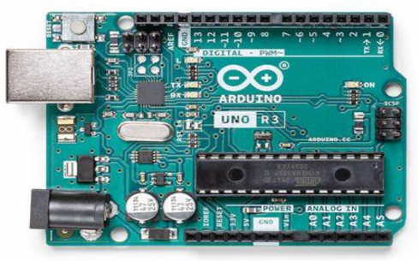

The Arduino Uno is a popular microcontroller board used for prototyping and developing electronics projects. It’s a part of the Arduino family of open-source hardware and software platforms, designed to make electronics accessible to artists, designers, hobbyists, and anyone interested in creating interactive projects.

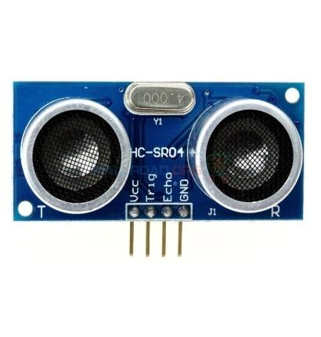

**4. Ultrasonic Sensor:**

The HC-SR04 ultrasonic sensor emits high-frequency sound waves and calculates the distance to an object by measuring the time it takes for the waves to bounce back. Widely used in robotics and automation, it provides accurate distance measurements in the range of 2cm to 4m.

**5. SG 90 Servo Motor:**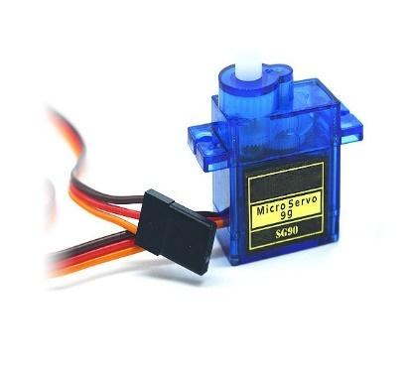

The SG90 servo motor is a compact, lightweight device capable of precise angular movement. It operates on low voltage and provides torque suitable for small-scale robotics and automation projects. With its affordability and versatility, it's widely used in hobbyist electronics and educational applications.

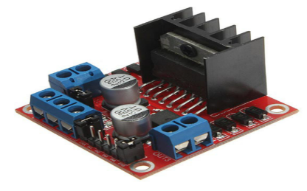

**6. L298N Motor Driver:**

The L298N is a popular dual H-bridge motor driver integrated circuit (IC) commonly used in robotics and electronics projects to control DC motors and stepper motors.

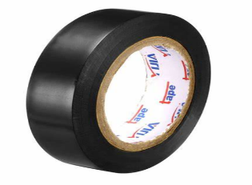

**7. Electrical Insulation Tape:**

Electrical insulation tape, commonly referred to as electrical tape or insulation tape, is a type of pressure-sensitive tape used to insulate electrical wires and other conductive materials.

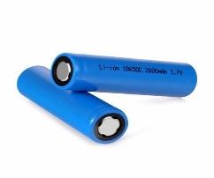

**8. Two 3.7 Volts DC Batteries:**

Two 3.7V DC batteries refers to a direct current (DC) power source that can provide a voltage output ranging from 7 volts to 12 volts.

**9. Jumper Wires:**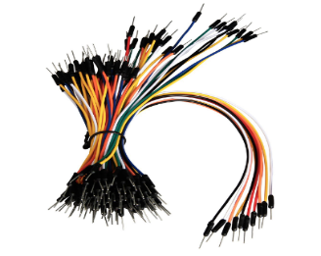

Jumper wires are electrical wires with connectors at each end, typically used to create electrical connections between various components on a breadboard, prototyping board, or electronic circuit.

**Working of Obstacle Avoidance Robot**

To construct an obstacle-avoiding robot, we assemble components systematically. First, the car chassis provides the base structure. TT Gear Motors enable movement, controlled by an Arduino Uno microcontroller. An ultrasonic sensor, mounted on the chassis, detects obstacles. The Arduino processes sensor data and determines the robot's movement. The L298N motor driver facilitates motor control. Electrical insulation tape secures connections. A 7-12 V DC battery powers the system. Jumper wires ensure proper connectivity. By integrating these components, the robot navigates autonomously, avoiding obstacles in its path, a vital feature in various applications, including automated guided vehicles and robotics competitions.

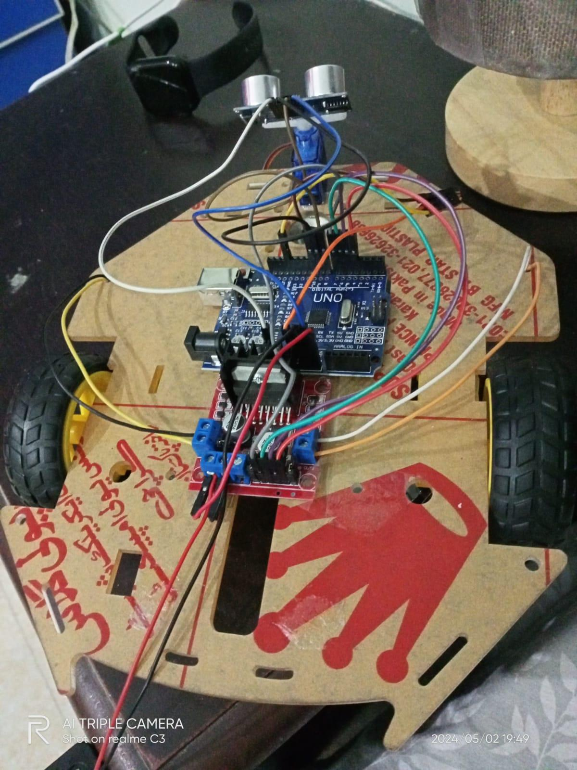

**Applications of Obstacle Avoidance Robot**

**- Industrial Automation:** The obstacle-avoiding robot streamlines manufacturing processes by autonomously navigating factory floors, safely avoiding obstacles, and transporting materials or performing tasks in hazardous environments.

**-** **Warehouse Logistics:** These robots optimize warehouse operations by efficiently maneuvering through aisles, avoiding collisions with shelves, and facilitating inventory management and order fulfillment processes.

**- Home Assistance:** Implementing obstacle-avoiding robots as personal assistants enhances home automation, enabling tasks such as cleaning and item retrieval while navigating around furniture and other obstacles.

**- Education and Research:** Obstacle-avoiding robots serve as valuable educational tools for students studying robotics and automation, offering hands-on experience with sensors, microcontrollers, and motor control systems.

**- Agricultural Robotics:** In agriculture, these robots contribute to precision farming techniques by navigating fields, identifying obstacles like rocks or irrigation lines, and assisting in crop monitoring and management tasks.

**Technical Errors & Troubleshoot Process**

Encountering a technical impasse during the development of our obstacle-avoiding robot project prompted a meticulous review of our circuitry and troubleshooting efforts. Initially, we meticulously examined the wiring of the entire circuit, ensuring each connection was correctly established. Despite our thoroughness, the robot failed to operate as expected. Recognizing the gravity of the situation, we embarked on a comprehensive troubleshooting process. Our troubleshooting journey began with a methodical recheck of every wire, connector, and component. Each connection was scrutinized for potential faults or loose ends, yet our efforts failed to yield a solution.

Seeking additional expertise, we enlisted the assistance of a senior student from the electrical department. Their seasoned insights and experience provided a fresh perspective on the problem at hand. Together, we conducted a detailed examination of the Arduino Uno microcontroller and its interaction with other components. Our collaborative troubleshooting efforts included testing individual components, inspecting code logic, and exploring potential software glitches. Despite our collective expertise and diligent examination, the root cause of the technical error remained elusive.

Looking ahead, we remain resolute in our commitment to overcoming this technical obstacle and bringing our obstacle-avoiding robot project to fruition. In the near future, we aim to embark on a more systematic approach to troubleshooting, leveraging additional resources and exploring alternative solutions. Through continued perseverance and collaborative effort, we are confident that we can unravel the complexities of our project and realize its full potential. This experience has reinforced the importance of resilience and interdisciplinary collaboration in engineering endeavors, and we are determined to apply the lessons learned to propel our project forward towards success.

**Conclusion**

In conclusion, the Obstacle Avoiding Robot project has been a significant learning experience. Through the design, construction, and testing phases, we have successfully developed a functional robot capable of autonomously following a predefined path. Our robot demonstrated efficient line detection and navigation, showcasing the effectiveness of the sensors and control algorithms implemented. However, challenges such as fine-tuning the PID parameters for optimal performance and addressing environmental factors affecting sensor accuracy were encountered along the way.

Despite these challenges, the project has provided valuable insights into robotics, sensor integration, and control systems. Moving forward, further enhancements could be made to improve the robot's robustness and adaptability to different environments. Overall, the project has not only reinforced theoretical concepts but also fostered practical problem-solving skills, making it a rewarding and enriching experience for all involved.

**References**

* [Step Wise Construction Of Obstacle Avoiding Robot](https://www.youtube.com/watch?v=kPSBpfUpHt0&t=322s)